Χρόνια πολλά! Χριστός Ανέστη!
Ελπίζουμε να περάσατε όλοι καλά!
Για οτιδήποτε χρειαστείτε μπορείτε να επικοινωνείτε μαζί μας μέσω email. Tα email μας είναι:
Μαρία Μπουγιατάκη: butterflymar2003@yahoo.com
Κική Καββάδα : kiki_kavada@hotmail.com

Αυτή την εβδομάδα θα ασχοληθούμε με την Unit 4.
Μπορείτε να μπείτε πάλι στα Διαδραστικά σχολικά βιβλία:
ebooks.edu.gr → Υλικό ανά τάξη → Στ’ δημοτικού → διαδραστικά βιβλία εμπλουτισμένα → Αγγλικά (Στ΄ Δημοτικού) – Βιβλίο μαθητή (Εμπλουτισμένο html) → (πάνω δεξιά) Unit 4 (ανοίγετε την κάθε ενότητα πατώντας πάνω σε κάθε lesson) Lesson 1: A day at the museum / Lesson 2 : An air pocket / Lesson 3 : the Fall of Icarus.

Αυτά είναι τα links που θα σας πάνε κατευθείαν στις αντίστοιχες σελίδες (με control + κλικ πάνω στον σύνδεσμο).
http://ebooks.edu.gr/modules/ebook/show.php/DSDIM-F101/441/2925,11599/
http://ebooks.edu.gr/modules/ebook/show.php/DSDIM-F101/441/2925,11600/
http://ebooks.edu.gr/modules/ebook/show.php/DSDIM-F101/441/2925,11601/

Στην αρχή κάθε σελίδας και ανάμεσα στις δραστηριότητες του βιβλίου θα βρείτε τα παρακάτω εικονίδια.

Όταν τα πατήσετε θα βρείτε ασκήσεις και παιχνίδια για όσα έχουμε μάθει. Αν κάποια δεν ανοίγουν μπορεί να μην υποστηρίζονται από τις εφαρμογές του υπολογιστή σας. Σε αυτή την περίπτωση πηγαίνετε στο επόμενο εικονίδιο. Έτσι θα κάνετε μια διασκεδαστική επανάληψη.

Και τώρα ασκήσεις για εξάσκηση.

- Complete. Use the Past Simple or the Past Continuous.

  - Jane ........................................ (sit) on her desk when the teacher ........................................ (walk) into the classroom.
walked
was sitting
  - I ........................................ (ride) my bike when I suddenly ........................................ (see) a dog in the road.
  - While the children ........................................ (play) a computer game, their mother ........................................ (make) supper.
  - Sue ........................................ (not study) French at two o’clock yesterday afternoon. She ........................................ (practise) the piano.
  - At 8 o’clock last night the baby ........................................ (sleep).
  - They ........................................ (dance) when the music suddenly ........................................ (stop).
  - What ........................................ (happen) to Pete when he ........................................ (fall) off the wall?
  - We ........................................ (not eat) lunch when Mum ........................................ (come) home.

- Circle the correct answer.

  - My parents bought / were buying a new car last month.
  - We were still working / worked on our project at seven o’clock last night.
  - Were you talking / Did you talk to James yesterday?
  - It didn’t rain / wasn’t raining when I left the house this morning.
  - What were you doing while / when Paul was doing his homework?
  - Sue was practising the piano when Dad came / was coming home.
  - We were walking / walked in the park when we saw Vicky and Ned.

- Complete. Use the Past Simple or Past Continuous form of the verbs below.

prepare not go do not take wait take part

  - I stayed at home yesterday. I .............................................. out.
didn’t go
  - Rob walked to school this morning. He ........................................ the bus.
  - While Pete .............................................. lunch, Ann was reading her book.
  - What .............................. you .............................. between nine o’clock and 11 o’clock last night?
  - .............................. the boys .............................. in the competition last Friday?
  - When I arrived at school, Jane .............................................. for me.

- Complete. Use the Past Simple or Past Continuous form of the verbs given.

Last week, while we (1) .............................................. (watch) TV, we (2) .............................................. (hear) a strange noise in the garden. It sounded like someone (3) .............................................. (cry). My dad (4) .............................................. (go) outside but he (5) .............................................. (not see) anything. While I
(6) .............................................. (get ready) for bed that night, I (7) .............................................. (see) something move quickly across the floor. I (8) .............................................. (look) under my bed and (9) .............................................. (find) a tiny cat. Suddenly, it (10) .............................................. (run) towards the window and (11) .............................................. (jump) out!
were watching

- Click and visit the National Gallery in London.
https://www.nationalgallery.org.uk/paintings/the-easter-story

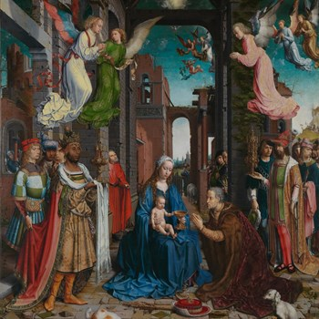

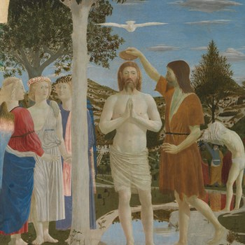

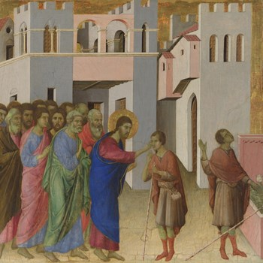
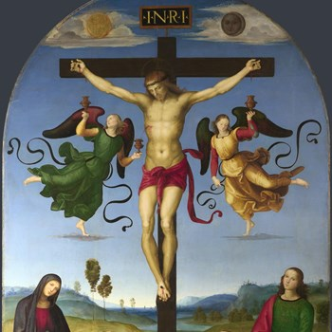

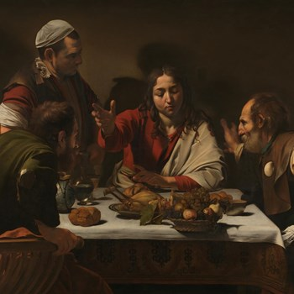

- Match the title of the painting to each painting depicting the life of Christ.
The Healing of the Man Born Blind
The Adoration of the Kings
The Supper at Emmaus
The Baptism of Christ
The Mond Crucifixion

- Click to check your answers:
https://www.nationalgallery.org.uk/paintings/short-tour-life-of-christ

