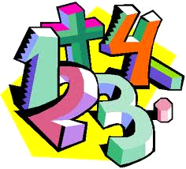
Όνομα: .............................................................

Μονάδες και δεκάδες

1. Βάζω σε κύκλο τα νομίσματα που χρειάζονται για να αγοράσω...

14 € | 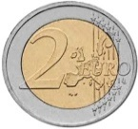  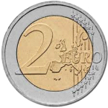  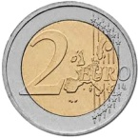
6 € | 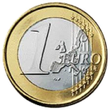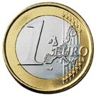
38 €
57 λεπτά | 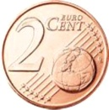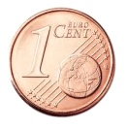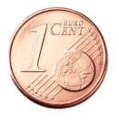

2. Συμπληρώνω τις ισότητες.

10 + 5 = ......... 10 + ......... = 12
10 + 8 = ......... 10 + ......... = 19
10 + 6 = ......... 10 + ......... = 14
10 + 3 = ......... 10 + ......... = 15
10 + 7 = ......... 10 + ......... = 11

17 – 7 = ......... 18 - ......... = 10
14 – 4 = ......... 16 - ......... = 10
13 – 3 = ......... 13 - ......... = 10
19 – 9 = ......... 12 - ......... = 10
12 – 2 = ......... 15 - ......... = 10

3. Συνεχίζω, όπως στο παράδειγμα.

25 = 10 + 10 + 5 36 = 10 + 10 + 10 + 6
27 = ...... + ...... + ...... 32 = ...... + ...... + ...... + ......
29 = ...... + ...... + ...... 33 = ...... + ...... + ...... + ......
22 = ...... + ...... + ...... 39 = ...... + ...... + ...... + ......

45 = ...... + ...... + ...... + ...... + ......
47 = ...... + ...... + ...... + ...... + ......

